**FITFOOD,**

**An Online Mobile Application for Food Delivery**

**User Guidelines for Customers**

Table of contents

1) Registration 3

2) Log In 5

3) Post Login 7

• Homepage 9

• Cart 12

• Checkout 14

4) Logging Out 16

# 1) Registration

To access the application, the users are required to be registered first. If they are not registered yet, they can register by clicking the ‘Register Now’ button.

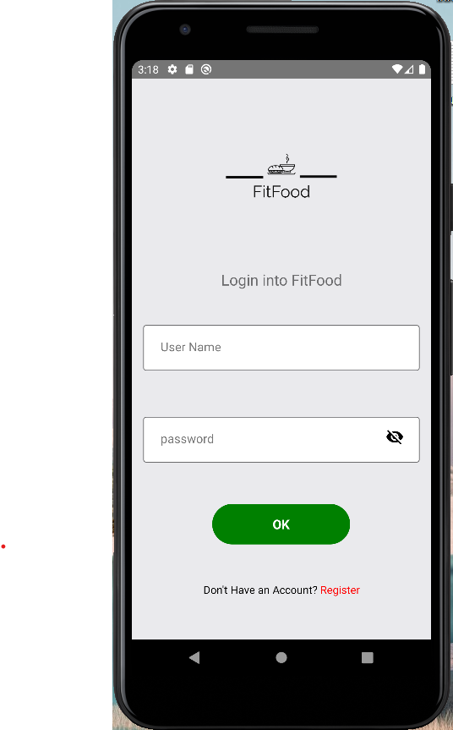

The users will be redirected to the registration form for users. After filling in the details, they must click the ‘Register button’ to submit the form.

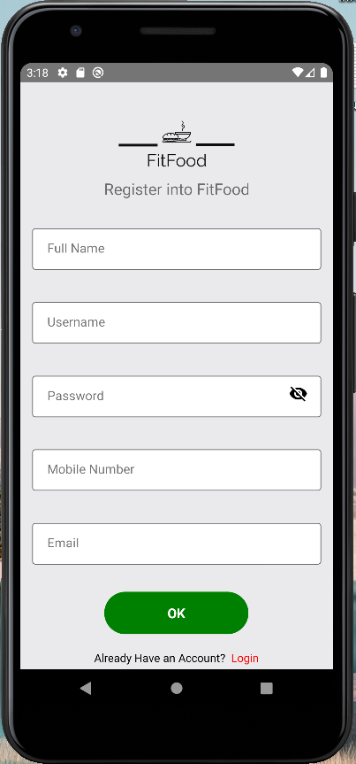

# 2) Log In

The users will be able to log in to the application by filling in a form using their Username and Password.



# 3) Post Login

After logging into the application, the users are provided with the rights to various features as discussed below. They have access to view the restaurants, their digital menu, add to the carts and proceed to check out.

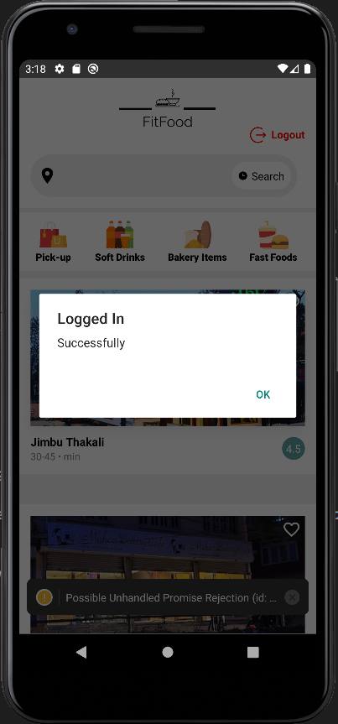

### Homepage

The users are navigated to the home page where they can view the list of restaurants.

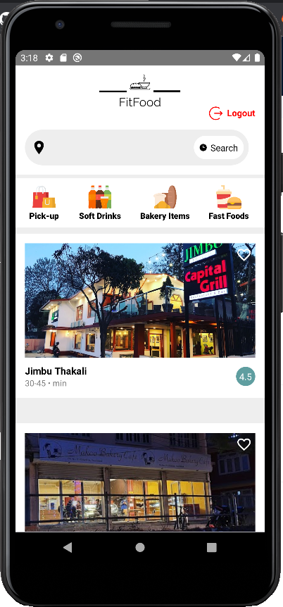

When the user clicks on a restaurant, they are navigated to the restaurant page where they can view the menu of the restaurant digitally.

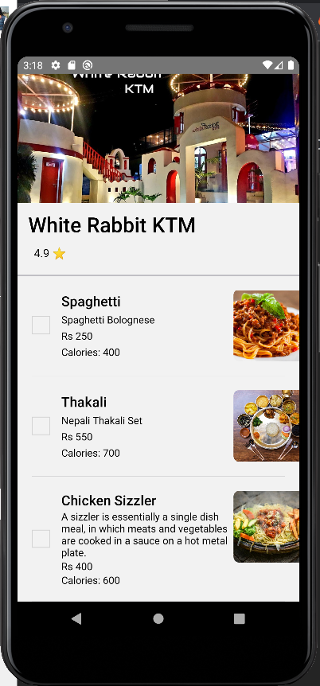

The users are able to add the item they prefer to the cart using the checkbox provided.

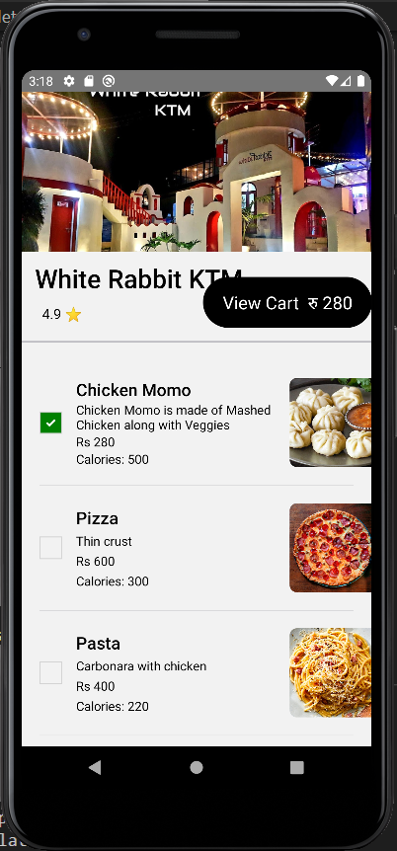

### Cart

The users will be able to add products to the cart by clicking the checkbox. The number of items added to the cart is displayed in the cart section when ‘view car’ is pressed.

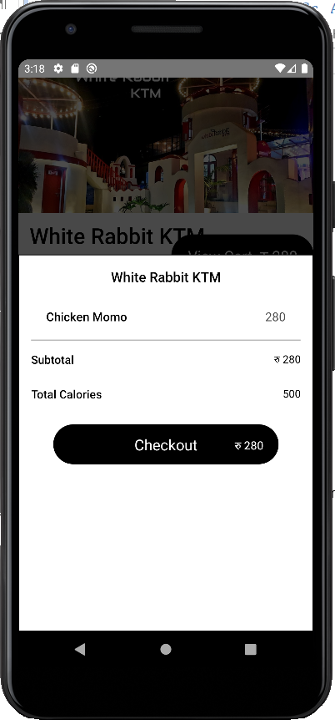

The users will be able to view the total items in the cart along with the price too. The total price including total calorie count is displayed in the cart section.

### Checkout

The users will be able to view the list of food items ordered which will be sent to the restaurants.

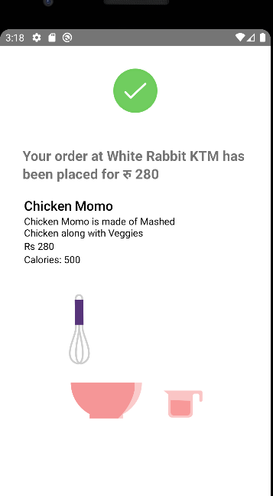

# 4) Logging Out

Users will be able to logout from the application using the logout button and they will be redirected to the login form page.

